A Hybrid Learning Framework for Automated Detection of Colorectal Cancer in Medical Images

Sahadeva Reddy Bollu
Ravindra College of Engineering for Women
Kurnool, Andhra Pradesh, India
sahadevareddy71@gmail.com
M. Balakrishna
Ravindra College of Engineering for Women
Kurnool, Andhra Pradesh, India
mkrishna223@gmail.com
K. Srinivasulu Achari
G Pullaiah College of Engg.and Technology
Kurnool, Andhra Pradesh, India
ksrinivasulua9@gmail.com

K. Manjusha
G Pullaiah College of Engineering and Technology
Kurnool, Andhra Pradesh, India
kothamanjusha9gmail.com
B. Thulasi
G Pullaiah College of Engineering and Technology
Kurnool, Andhra Pradesh, India
thulasi.beldari@gmail.com
U. Prem Sagar
G Pullaiah College of Engg. and Technology
Kurnool, Andhra Pradesh, India
premsagarrsp@gmail.com

Abstract—Colorectal cancer is still one of the main contributors to cancer-related deaths across the world. The early detection of the disease is essential in improving the prospects of survival for the patients. Recently, deep learning has been found to be quite promising in the detection of cancer through images. However, the conventional deep learning methods require significant computational powers and heavy training costs, which limit the application of the method in real-world scenarios. In this paper, we propose a cost-effective deep learning method for the detection of colorectal cancer using an unsupervised composite network to extract significant features from the images. The model enhances feature representation and improves classification performance without requiring extensive labeled datasets. Experimental results demonstrate that the proposed model improves diagnostic accuracy while significantly reducing training cost and computational requirements. Therefore, the proposed method can support efficient and early detection of colorectal cancer and contribute to the development of intelligent medical diagnosis systems.
Keywords—Deep Learning, Unsupervised Learning, Colorectal Cancer Diagnosis, Medical Image Analysis, Composite Neural Network, Computer-Aided Diagnosis

Introduction
Colorectal cancer (CRC) is a major health problem globally. It is among the leading causes of cancer-related mortality. It is also among the leading types of cancer diagnosed globally. The management of CRC requires early diagnosis. This is because the biological behavior of the cancer differs from one patient to another [1]. The identification of the various characteristics of the patients is crucial in the management of the cancer. This will help in the formulation of a precise management plan for the patients. Recently, there have been developments in the application [5] of artificial intelligence (AI) in the improvement of medical diagnostics. AI is a branch of computer science focused on the simulation of human intelligence. It involves the study of the processes of learning, reasoning, and problem-solving. Among the recent developments in AI is the recognition of the importance of machine learning (ML) and deep learning (DL) [2], [3] in the analysis of medical data. These two have received a lot of attention in the improvement of medical diagnostics. They have been used in the improvement of various medical applications.
Among deep learning techniques, convolutional neural networks (CNNs) have shown remarkable results in processing medical images [4]. CNNs are deep networks that use various layers to automatically learn spatial and structural features from images. Due to their ability to handle complex high-dimensional visual data, CNNs are often [6] employed in various applications, including tumor detection, cancer classification, and disease staging. In the field of colorectal cancer, deep learning techniques have shown promising results in improving diagnostic accuracy and assisting clinicians in their decision-making process [8].
Additionally, with the increasing adoption of various medical imaging techniques, such as computed tomography scans and magnetic resonance imaging, a huge amount of diagnostic data can now be obtained [7]. Deep learning techniques can utilize this data to identify meaningful features that can aid clinicians in identifying the early signs of colorectal cancer [9]. These intelligent systems can improve diagnostic efficiency and reduce the workload of healthcare professionals. In spite of these advantages, traditional deep learning models are often associated with high demands in terms of data sets and computational resources. Data annotation is one of the major issues in implementing traditional deep learning models in the field of computer-aided diagnosis [10]. Data annotation is a very complex and time-consuming process in the field of medical imaging. In order to address the issues associated with traditional deep learning models, the current study proposed a cost-effective deep learning model for the diagnosis of colorectal cancer based on an unsupervised composite network [11].
Deep learning algorithms require properly annotated training data for optimal performance. In supervised learning approaches, region of interest (ROI) annotation is necessary for effectively training computer vision algorithms [12], [13]. However, ROI annotation is a time-consuming process and involves significant cost, particularly for large-scale medical image datasets [14]. Moreover, it requires expert knowledge from radiologists for accurate pixel-level annotation, which further increases the complexity when dealing with extensive datasets [15].To overcome these challenges, unsupervised learning techniques are employed to analyze unlabeled medical data, enabling the discovery of hidden patterns within the dataset [16]. Among various unsupervised learning methods, the K-means clustering algorithm is widely used due to its simplicity and efficiency when applied to large-scale datasets [17].
To this end, in this paper, we present a combined method, referred to as RK-Net, which leverages both unsupervised clustering techniques and lightweight convolutional neural networks to perform the task of efficient colorectal cancer detection from CT images. Namely, K-means clustering is utilized to remove the noise from the input image and MobileNetV2 is adopted to extract features and perform classification. As mentioned above, this work is distinct from previous works that employ related techniques, for example, in multispectral or geospatial imagery, in that no new algorithms have been developed specifically for this paper. Rather, we concentrate our attention on the application of existing methods for solving a practical problem in the field of medicine. The structure of the rest of the paper is outlined as follows. Section II explains the proposed RK-Net methodology. In Section III, we discuss the experimental results obtained using the suggested technique.

Method

Original Research on Deep Learning for Colorectal Cancer Diagnosis
In this study, data from 360 patients diagnosed with colorectal cancer were collected from the database of the Sixth Affiliated Hospital of Sun Yatsen University (SAH-SYSU), located in Guangzhou, China.
Based on the pathological diagnosis results, the patients were categorized into two groups, namely Class 1 and Class 2, with an equal number of patients in each class. The inclusion criteria for the patients in this study were as follows: (1) confirmed diagnosis of colorectal adenocarcinoma, (2) age between 18 and 80 years, and (3) availability of complete clinical and imaging information. Patients with malignancies other than colorectal cancer were excluded from the study.
The imaging data obtained from the patients were stored in Digital Imaging and Communications in Medicine (DICOM) format. The reliability and accuracy of the collected dataset were verified by two experienced clinicians.

Datasets
The dataset was randomly divided into 300 patients for training and 60 patients for testing. All samples were categorized into two classes according to their corresponding labels. To evaluate the effectiveness of the proposed method, three different image processing approaches were considered.
First, the proposed RK-net framework was designed to automatically remove irrelevant image slices while retaining slices containing tumor-related information. Second, manual annotation was performed to generate segmented images based on regions of interest (ROIs). The tumor ROIs were manually outlined using the ITK-SNAP software tool. Third, a manual screening approach was applied in which experienced radiologists removed irrelevant slices from the dataset based on their clinical judgment.
The medical images were originally stored in Digital Imaging and Communications in Medicine (DICOM) format and later converted into Neuroimaging Informatics Technology Initiative (NIfTI) files for further processing. The Python OpenCV library was then used to split the NIfTI files into axial image slices for subsequent analysis.

Platform building
For data processing and model training, a high-performance computing system was utilized in this study. The experimental environment consisted of an Intel Xeon Silver CPU, 64 GB of DDR4 RAM, and an NVIDIA RTX 3080 GPU to ensure efficient training of the proposed model. For GPU acceleration, CUDA Toolkit 11.x and cuDNN 8.x were utilized to optimize parallel computations. The development environment was configured using the Anaconda distribution, which served as the base platform for building and training the deep learning model. The software stack included Python 3.9 and TensorFlow-GPU 2.x. Additionally, the NVIDIA System Management Interface (nvidia-smi) was employed to monitor GPU performance and resource utilization during the training process.

Proposed RK-Net Architecture
The RK-Net model is a hybrid model used for medical image processing and facilitating the diagnosis of colorectal cancer. The model consists of different sections, each dealing with a different aspect of data prep and feature extraction. The first part is used for preprocessing medical images by batch processing the raw data and transforming it into a more manageable format for analysis. In this part, unnecessary in- formation is removed while patient confidentiality is ensured.
The second component utilizes the MobileNetV2 structure to extract the features and perform the image classification. MobileNetV2 is based on an inverted residual architecture that includes thin bottleneck layers and shortcut connections between layers, as illustrated in Fig. 1. This structure enables efficient extraction of meaningful features from medical images. The model is initially pre-trained on large-scale public datasets and later fine-tuned for colorectal cancer image analysis [18].
The third component in the RK-net framework is the unsupervised classifier, which makes use of the K-means clustering algorithm. This component is used in the pre-classification of the image data in order to differentiate between relevant and irrelevant image slices. For the K-means clustering algorithm, the aim is to minimize the sum of the squared distances between the data and their respective cluster centers:

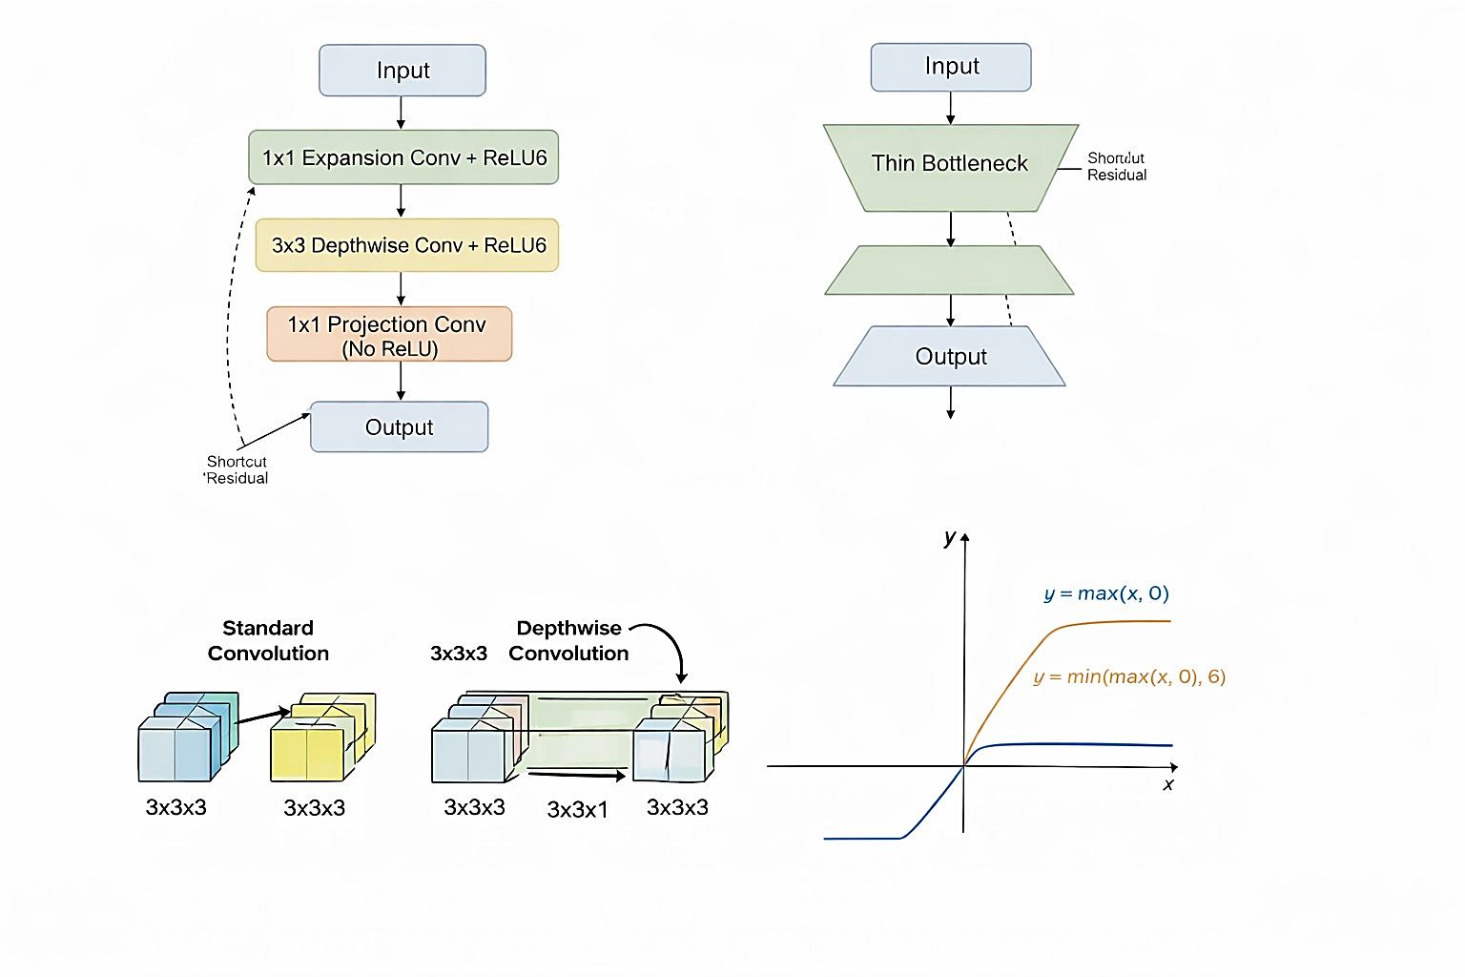
- Architecture of the MobileNetV2 bottleneck layer showing the inverted residual structure with 1×1 expansion convolution, 3×3 depthwise convolution, and 1×1 linear projection layers.

$E=\sum_{i=1}^{K}{\sum_{x∈C_{i}}{{\left\|x-μ_{i}\right\|}_{2}^{2}}}$ (1)
$μ_{i}=\frac{1}{\left|C_{i}\right|}\sum_{x∈C_{i}}{x}$ (2)
Here, x is the sample, k is the number of clusters, C_{i} represents the set of samples in the cluster i, µ_{i} is the mean of the cluster, and E is the total squared error [19], [20]. The lower the value of E, the higher the similarity between the samples in the same cluster. For the purpose of the current research, k = 2 was applied to filter out the irrelevant images from the data set. The classification results were exported as CSV files, and the images were arranged in folders based on certain criteria.
The final component of the RK-Net framework is the image formatting module. The module, based on OpenCV, deals with the conversion of the received images into a format suitable for the next steps. It makes use of the results from the classification based on the clustering stage in order to filter the images and retain only the ones required for the next step.
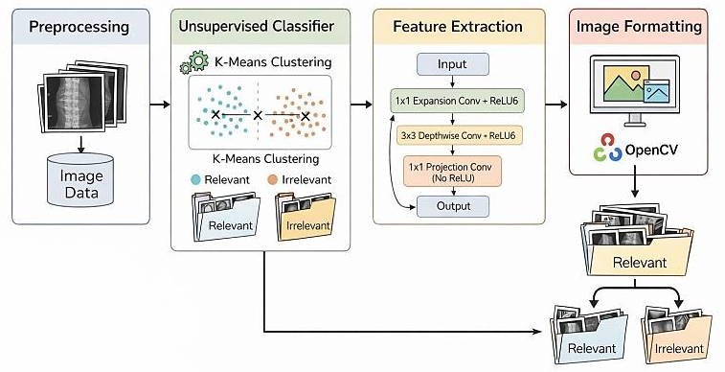
- The architecture of RK-net
The RK-net in its entirety, including its architecture and framework

CRC DIAGNOSTIC MODE

Proposed CRC Diagnostic Model Using RK-Net
The framework for diagnosing colorectal cancer (CRC) incorporates RK-Net to facilitate efficient and cost-effective medical image analysis. The framework comprises four key steps: preprocessing, unsupervised classification, deep feature extraction, and image formatting, which collectively contribute to improved accuracy in cancer detection. Moving forward, preprocessing filters medical images to remove unwanted data or ”noise” and normalize all images to ensure consistency in format. The next stage in medical image analysis is unsupervised classification, which relies on K-means clustering to classify image slices as relevant or non-relevant to cancer detection. By discarding non-relevant slices, the framework eliminates unnecessary data to improve efficiency in medical image analysis. Next, we make use of deep feature extraction using MobileNetV2, which has an inverted residual connection that helps in representing the images without requiring complex computations. In the final step, the images are formatted and classified using OpenCV based on the classification results and are utilized for precise diagnosis of colorectal cancer.

Evaluation Metrics
The effectiveness of the suggested framework for diagnosing colorectal cancer, which is developed using RK-Net, is assessed using a number of metrics that are commonly applied in medical image classification problems. These metrics offer a holistic idea of how well the model identifies colorectal cancer, how robust it is, and how effective it is in interpreting medical images.
- Accuracy (ACC): Represents the share of correctly identified images out of the total set of images evaluated.
$ACC=\frac{TP+TN}{TP+TN+FP+FN}$ (3)
- Precision (P): The metric is the proportion of true positive predictions among all instances that were predicted as positive.
$P=\frac{TP}{TP+FP}$ (4)
- Recall (Sensitivity, R): Describes how well the model identifies real positive cases.
$R=\frac{TP}{TP+FN}$ (5)
- F1-Score (F1):A combination of both of these metrics, as viewed together, is achieved through the application of the harmonic mean of both of these metrics.
$F1=2×\frac{P×R}{P+R}$ (6)
- Specificity (SP): Measures the degree of effectiveness of the model in detecting true negatives.
$SP=\frac{TN}{TN+FP}$ (7)

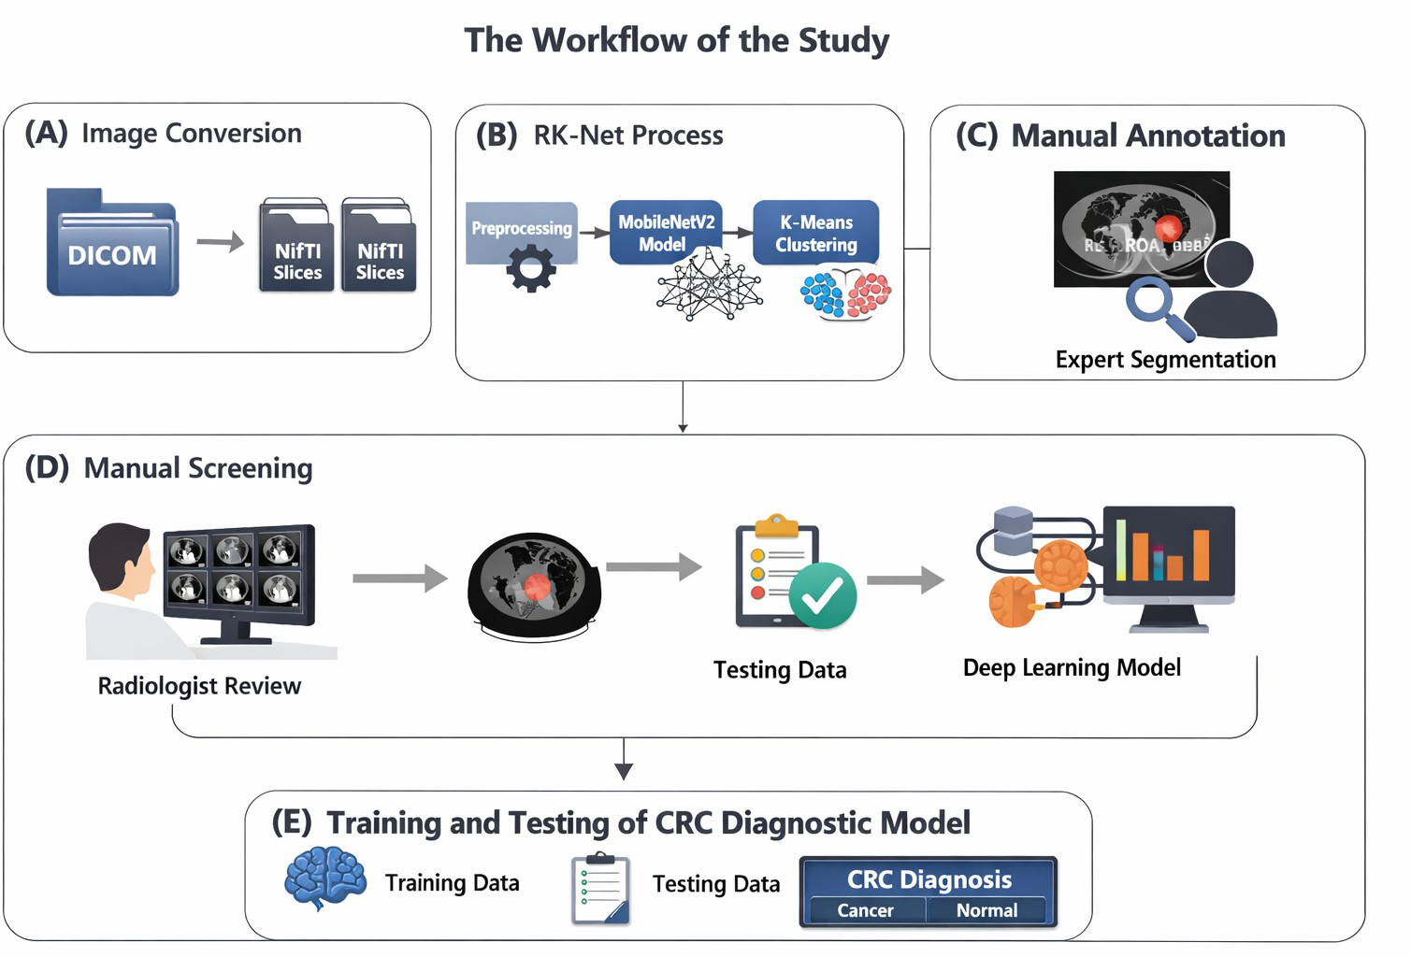
- Explanation of the workflow of the study in simple terms: the images are converted, followed by the processing of the images using RK-Net, then the annotation of the images, followed by the screening of the images, and then the testing of the model for the diagnosis of colorectal cancer (CRC).
Here, TP, TN, FP, and FN denote true positives, true negatives, false positives, and false negatives, respectively. All the metrics provide a comprehensive assessment of the level at which the proposed model can diagnose.
False Negative Rate (FNR) is the proportion of true positive instances incorrectly classified by the model as negative. It is given by:
$FNR=\frac{FN}{TP+FN}$ (8)
FNR in this study means the probability that a patient who actually belongs to Class 1 is misclassified into one of the other classes. Class 2.
1) Accuracy: Accuracy measures the accuracy of the model, i.e., how correct the model is, based on the percentage of the cases that the model correctly classifies as true positives and true negatives out of all the cases considered.
$Accuracy=\frac{TP+TN}{TP+TN+FP+FN}$ (9)
Here, accuracy refers to the probability that the patient in the data set receives the correct diagnosis.

Work Flow
Three datasets were loaded into the CRC diagnostic model using the previously described platform. The CT images were converted into a readable format using programming tools and saved as PNG files. The time required for data preprocessing and model training was recorded to evaluate computational efficiency. Subsequently, the diagnostic performance of the CRC model was assessed. The workflow for the training and testing process is illustrated in Fig. 4.

Results and discussions
The RK-Net approach significantly reduced the time required for data preprocessing and model training, as illustrated in Fig. 5 In contrast, manual annotation required over 100 times more time compared to the RK-Net-based processing.
Furthermore, the RK-Net approach enabled image preprocessing for training the colorectal cancer diagnostic model to be completed in half the time required by conventional preprocessing methods.
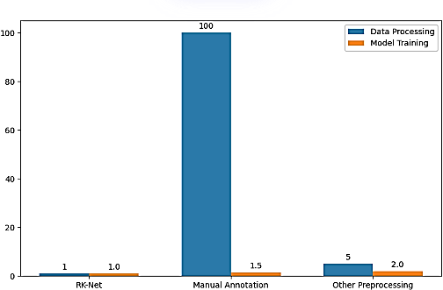
- Time spent on data processing and training the CRC diagnostic model.
The RK-Net framework not only reduced the time required for data preprocessing but also enabled the colorectal cancer diagnostic model to train at approximately twice the speed of conventional preprocessing methods. When using RK-Net- processed data, the model exhibited faster and more stable convergence. As shown in Fig. 5, the RK-Net approach substantially reduced the time required for data preprocessing and model training compared to manual annotation and other conventional preprocessing methods. Specifically, the training loss decreased to around 0.15 after 400 steps, whereas the manually screened data showed a similar trend but ended with a higher loss value. Concurrently, the model accuracy improved with decreasing loss, achieving values above 0.9 after 500 steps for both RK-Net and manually screened data, with RK-Net demonstrating faster convergence.
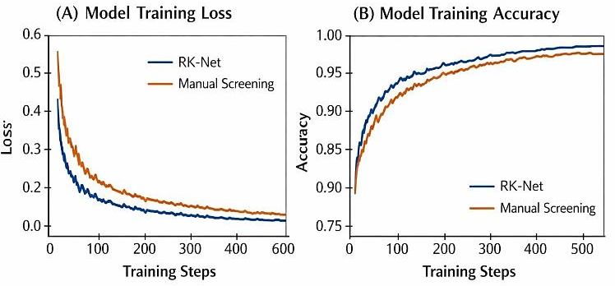
- The training loss and accuracy for the CRC diagnostic model are provided for different datasets. In Fig. 1, panel (A) indicates the training loss, while panel (B) indicates the training accuracy.
The performance of the proposed model for colorectal cancer (CRC) detection was evaluated using three different data sets, and the performance is represented in Table I. The performance of the proposed model is based on accuracy, precision, recall, F1-score, and false negative rate (FNR).
From Table I, it is clear that the proposed model performed well in terms of accuracy, where accuracy is 0.92, 0.90, and 0.94 for Dataset 1, Dataset 2, and Dataset 3, respectively. The performance of the proposed model is clear in that it is consistent in performance for different data sets, indicating that the proposed model is effective in terms of its predictive ability.
- Performance of the CRC diagnostic model using different datasets
Dataset | Accuracy | Precision | Recall | F1-Score | FNR
Dataset 1 | 0.92 | 0.91 | 0.93 | 0.92 | 0.07
Dataset 2 | 0.90 | 0.89 | 0.91 | 0.90 | 0.09
Dataset 3 | 0.94 | 0.93 | 0.95 | 0.94 | 0.05

From Table I, it is also clear that the proposed model performed well in terms of precision, where precision is 0.91, 0.89, and 0.93 for Dataset 1, Dataset 2, and Dataset 3, respectively. The performance of the proposed model is clear in that it is consistent in performance for different data sets, indicating that the proposed model is effective in terms of its ability to identify positive data sets for colorectal cancer detection.
From Table I, it is also clear that the proposed model performed well in terms of recall, where recall is 0.93, 0.91, and for the manually annotated dataset, the training loss remained between 0.6 and 0.8, while the accuracy was approximately 0.6 throughout the training period. In contrast, models trained using the RK-Net-processed dataset exhibited faster learning and superior performance.
These results are summarized in Table I. For the RK-Net- processed dataset (RM), the model achieved an accuracy of 0.95. In comparison, models trained on the manually screened dataset (SM) and manually annotated dataset (AM) attained accuracies of 0.93 and 0.72, respectively.
The present study demonstrates the effectiveness of RK-Net in reducing the complexity of deep networks for colorectal cancer diagnosis. By filtering out irrelevant images, RK-Net enables more efficient use of computational resources and accelerates model training without compromising diagnostic accuracy [21]. In conventional approaches, manual annotation of regions of interest (ROIs) is required, which is time-consuming and may introduce subjectivity [22]. Furthermore, manual ROI annotation can inadvertently remove important contextual information from adjacent anatomical structures [23].
With the increasing availability of big data and advances in computational power, there is a growing need for models that can efficiently and cost-effectively process medical imaging data. The RK-Net framework provides two benefits: It removes noisy and irrelevant images in complex medical datasets, retaining only the informative images required for tumor detection. It also increases the efficiency of subsequent deep learning models by minimizing redundant data, thereby speeding up the process and improving accuracy in diagnosing colorectal cancer [24].
The RK-Net utilizes the MobileNetV2 as the initial classifier due to its compact structure. The structure of the MobileNetV2 is based on the inverted residual blocks with linear bottlenecks, which minimizes the computational load through depth-wise separable convolution operations. This minimizes the memory usage during the inference process. In addition, the CNN can be easily implemented using Python-based deep learning libraries. The RK-Net can be efficiently implemented with the unsupervised classifier based on the K-means algorithm when It can be deployed on standard server infrastructures and does not require any special GPU hardware. The model can also be deployed as an accessible tool that can be used to assist in the diagnosis of colorectal cancer.
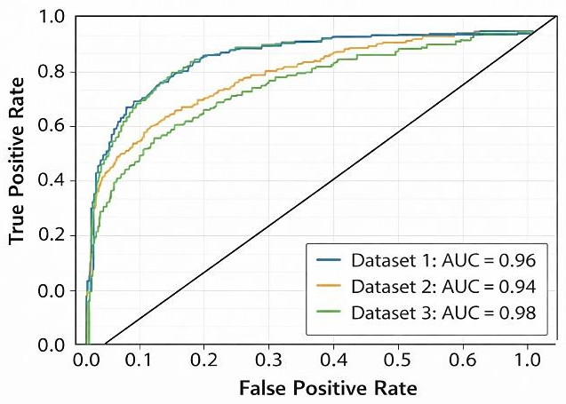
- ROC curves for medical image classification models
As illustrated in Fig. 6, the proposed model achieves a high classification performance for all datasets.
The Receiver Operating Characteristic (ROC) curve is utilized to evaluate the classification performance of the proposed model for colorectal cancer detection. The ROC curve illustrates the relationship between the True Positive Rate (TPR) and False Positive Rate (FPR) at different classification thresholds.
As shown in Fig. 6, the proposed model demonstrates strong discrimination capability across all datasets. The ROC curves are located close to the top-left corner, indicating high sensitivity and specificity in detecting cancerous medical images.
The effectiveness of the proposed model is further validated by the high Area Under the Curve (AUC) values obtained for all datasets. The AUC value for Dataset 1 is 0.96, while Dataset 2 achieved an AUC of 0.94. The highest AUC value is obtained for Dataset 3, which is 0.98.
A higher AUC value indicates better classification performance of the model in distinguishing between cancerous and non-cancerous medical images. The results demonstrate that the proposed deep learning model has strong potential for accurate and reliable colorectal cancer detection in medical image analysis.
However, the RK-Net framework has many benefits, but at the same time, it also has some gaps. The pre-trained models used are based on different medical image datasets, which might affect the performance of the RK-Net framework. Improvements in new algorithms are promising to achieve better classification results. In this regard, the refresh of the RK-Net framework’s functional modules might be required [25]. Currently, RK-Net is designed primarily for processing radiologic images, which may limit its applicability in multimodal imaging scenarios. To enable multimodal data fusion, further architectural upgrades are required. Additionally, the framework’s performance must be validated across diverse datasets and alternative algorithms to establish its generalizability and robustness.

Conclusion
Within this work, we propose the RK-net composite network, which combines elements of both deep learning and unsupervised learning for polishing radiologic images. RK-net has the ability to filter out irrelevant images, thereby reducing human factors that may influence the quality of the images. Besides removing the burden of manually screening images, RK-net ensures that the quality of the input images is high, thus improving the performance of deep neural networks. This provides an avenue for refining images within the medical field and building improved deep learning models.

Future Research Work
There are several avenues for extending the RK-Net frame- work, and some of them include the following:
One possible direction for extending the RK-Net framework is to experiment with the latest and best-in-class deep learning architectures, such as EfficientNet, Vision Transformers, and their hybrids, which combine CNN and Transformers, to improve feature extraction and classification accuracy. The second possible direction for extending the RK-Net framework is to extend the framework to handle multimodal medical data, such as CT, MRI, and histopathology images, together to improve the accuracy of medical diagnosis. The third possible direction for extending the RK-Net framework is to make better use of the large amounts of unlabeled medical data through the incorporation of self-supervised and semi-supervised learning. The final possible direction for extending the RK-Net framework is to validate the RK-Net framework with larger and diverse clinical data from various medical centers.
References
- H. Sung et al., “Global cancer statistics 2020: GLOBOCAN estimates of incidence and mortality worldwide for 36 cancers in 185 countries,” CA-Cancer J. Clin., vol. 71, no. 3, pp. 209–249, 2021, doi: 10.3322/caac.21660.
- N. H. C. O. China, “Chinese protocol of diagnosis and treatment of colorectal cancer (2020 edition),” Zhonghua Wai Ke Za Zhi, vol. 58, no. 8, pp. 561–585, 2020, doi: 10.3760/cma.j.cn112139-20200518-00390.
- S. Harada and D. Morlote, “Molecular pathology of colorectal cancer,” Adv. Anatomic Pathol., vol. 27, no. 1, pp. 20–26, Jan. 2020, doi: 10.1097/PAP.0000000000000247.
- S. Shalev-Shwartz, Understanding Machine Learning: From Theory to Algorithms. Cambridge Univ. Press, 2014.
- G. Rompianesi, F. Pegoraro, C. D. Ceresa, R. Montalti, and R. I. Troisi, “Artificial intelligence in the diagnosis and management of colorectal cancer liver metastases,” World J. Gastroenterol., vol. 28, no. 1, pp. 108–122, Jan. 2022, doi: 10.3748/wjg.v28.i1.108.
- K. Bera, K. A. Schalper, D. L. Rimm, V. Velcheti, and A. Madabhushi, “Artificial intelligence in digital pathology—New tools for diagnosis and precision oncology,” Nature Rev. Clin. Oncol., vol. 16, no. 11, pp. 703–715, Nov. 2019, doi: 10.1038/s41571-019-0252-y.
- S. Kuntz et al., “Gastrointestinal cancer classification and prognostica- tion from histology using deep learning: Systematic review,” Eur. J. Can- cer, vol. 155, pp. 200–215, Sep. 2021, doi: 10.1016/j.ejca.2021.07.012.
- C. Wong et al., “MRI-based artificial intelligence in rectal cancer,” J. Magn. Reson. Imag., 2022, doi: 10.1002/jmri.28381.
- M. A. Van De Wiel, M. Neerincx, T. E. Buffart, D. Sie, and H. M. Verheul, “ShrinkBayes: A versatile R-package for analysis of count- based sequencing data in complex study designs,” BMC Bioinf., vol. 15, no. 1, p. 116, Dec. 2014, doi: 10.1186/1471-2105-15-116.
- C. Lovis, “Unlocking the power of artificial intelligence and big data in medicine,” J. Med. Internet Res., vol. 21, no. 11, Nov. 2019, Art. no. e16607, doi: 10.2196/16607.
- Y. Wang, X. He, H. Nie, J. Zhou, P. Cao, and C. Ou, “Application of artificial intelligence to the diagnosis and therapy of colorectal cancer,” Amer. J. Cancer Res., vol. 10, no. 11, pp. 3575–3598, 2020.
- H. Qiu, S. Ding, J. Liu, L. Wang, and X. Wang, “Applications of artificial intelligence in screening, diagnosis, treatment, and prognosis of colorectal cancer,” Current Oncol., vol. 29, no. 3, pp. 1773–1795, Mar. 2022, doi: 10.3390/curroncol29030146.
- Y. Hu et al., “Computed tomography-based deep-learning prediction of neoadjuvant chemoradiotherapy treatment response in esophageal squamous cell carcinoma,” Radiother Oncol., vol. 154, pp. 6–13, Jan. 2021, doi: 10.1016/j.radonc.2020.09.014.
- D. Jin et al., “DeepTarget: Gross tumor and clinical target, volume segmentation in esophageal cancer radiotherapy,” Med. Image Anal., vol. 68, Feb. 2021, Art. no. 101909, doi: 10.1016/j.media.2020.101909.
- M. A. Berb´ıs, J. Aneiros-Ferna´ndez, F. J. M. Olivares, E. Nava, and
- A. Luna, “Role of artificial intelligence in multidisciplinary imaging diagnosis of gastrointestinal diseases,” World J. Gastroenterol., vol. 27, no. 27, pp. 4395–4412, Jul. 2021, doi: 10.3748/wjg.v27.i27.4395.
- K. Raza and N. K. Singh, “A tour of unsupervised deep learning for medical image analysis,” Current Med. Imag. Formerly Current Med. Imag. Rev., vol. 17, no. 9, pp. 1059–1077, Sep. 2021, doi: 10.2174/1573405617666210127154257.
- A. Walker and P. Surda, “Unsupervised learning techniques for the investigation of chronic rhinosinusitis,” Ann. Otology, Rhinol- ogy Laryngology, vol. 128, no. 12, pp. 1170–1176, Dec. 2019, doi: 10.1177/0003489419863822.
- M. Sandler, A. Howard, M. Zhu, A. Zhmoginov, and L.-C. Chen, “MobileNetV2: Inverted residuals and linear bottlenecks,” in Proc. IEEE/CVF Conf. Comput. Vis. Pattern Recognit., Jun. 2018, pp. 4510– 4520.
- A. K. Jain, “Data clustering: 50 years beyond K-means,” in Proc. Joint Eur. Conf. Mach. Learn. Knowl. Discovery Databases, 2008, pp. 3–4.
- C. Chinrungrueng and C. H. Sequin, “Optimal adaptive K-means algo- rithm with dynamic adjustment of learning rate,” IEEE Trans. Neural Netw., vol. 6, no. 1, pp. 157–169, Jan. 1995, doi: 10.1109/72.363440.
- H. Xiao et al., “A review of deep learning-based three-dimensional medical image registration methods,” Quant. Imag. Med. Surgery, vol. 11, no. 12, pp. 4895–4916, 2021, doi: 10.21037/qims-21-175.
- A. Kleppe, O.-J. Skrede, S. De Raedt, K. Liestøl, D. J. Kerr, and H.
- E. Danielsen, “Designing deep learning studies in cancer diagnostics,” Nature Rev. Cancer, vol. 21, no. 3, pp. 199–211, Mar. 2021, doi: 10.1038/s41568-020-00327-9.
- C. Le Berre et al., “Application of artificial intelligence to gastroenterol- ogy and hepatology,” Gastroenterology, vol. 158, no. 1, p. 76, 2020, doi: 10.1053/j.gastro.2019.08.058.
- R. Bommasani et al., “On the opportunities and risks of foundation models,” 2022, arXiv:2108.07258.
- X. Gao, F. Shi, D. Shen, and M. Liu, “Task-induced pyramid and attention GAN for multimodal brain image imputation and classification in Alzheimer’s disease,” IEEE J. Biomed. Health Informat., vol. 26, no. 1, pp. 36–43, Jan. 2022, doi: 10.1109/JBHI.2021.3097721.

