A Comprehensive Framework for Corpus Callosum Segmentation to Identify Callosal Abnormalities and Genetic Associations Using Multi-Contrast MRI

Sahadeva Reddy Bollu
Dept. of Computer Science and Engineering
Ravindra College of Engineering for Women Kurnool
Andhra Pradesh, India
sahadevareddy71@gmail.com
M. Balakrishna
Dept. of Computer Science and Engineering
Ravindra College of Engineering for Women Kurnool
Andhra Pradesh, India
mkrishna223@gmail.com
G. Lucy
Dept. of Computer Science and Engineering
Ravindra College of Engineering for Women Kurnool
Andhra Pradesh, India
lucygk115@gmail.com

Abstract—The corpus callosum (CC), which is the largest white matter component in the human brain, is known to be very important for interhemispheric connections. It has been found to have a connection with a variety of neurological and developmental issues whenever there are structural problems with it. Changes in the shape of the corpus callosum, like its absence, underdevelopment, or poor development, usually co- occur with other problems in the brain and genetics, making it necessary to detect it earlier on. MRI techniques can help in the detection and analysis of the corpus callosum. The Results from experimental evaluation show that the suggested framework exhibits excellent performance in terms of high segmentation accuracy, increased robustness to changes in images, and increased ability in identifying clinically relevant callosal abnormalities. Incorporation of genetic association studies allows researchers to develop a greater insight into neurodevelopmental diseases, enabling precision medicine programs. This framework can be considered scalable and clinically relevant for neuroimaging analysis purposes is paper aims at suggesting a complete automatic pipeline for corpus callosum segmentation and abnormality detection through MRI imaging with multiple contrasts along with the application of artificial intelligence. The suggested method utilizes deep learning based segmentation algorithms that not only help in segmentation of corpus callosum, but also extract the morphological characteristics like size, volume, and curvatures. There is also a separate module to perform quality control and validation of the extracted features. Besides, statistical and machine learning based analysis has also been performed in the paper in order to detect abnormalities. Results from experimental evaluation show that the suggested framework exhibits excellent performance in terms of high segmentation accuracy, increased robustness to changes in images, and increased ability in identifying clinically relevant callosal abnormalities. Incorporation of genetic association studies allows researchers to develop a greater insight into neurodevelopmental diseases, enabling precision medicine programs. This framework can be considered scalable and clinically relevant for neuroimaging analysis purposes.
Keywords—Corpus Callosum, MRI, Medical Image Seg- mentation, Deep Learning, Neuroimaging, Genetic Association, Multi-Contrast MRI, Brain Abnormalities

Introduction
Corpus Callosum (CC) is the biggest white matter structure found in the human brain. which connects both halves of the brain. CC is responsible for transferring messages from one half of the brain to the other. This structure is crucial in integrating motor, sensory, and cognitive functions [1]. Developmental or anatomical anomalies of CC, like absence, underdevelopment, and malformation, are strongly linked to neurological disorders like autism spectrum disorder, epilepsy, schizophrenia, and mental retardation. It is important that segmentation and volume quantification of an object can be done with high accuracy. The corpus callosum is an essential issue, as it allows for early diagnosis and treatment planning for the disorders [2]. Therefore, automatic segmentation and measurement of the CC is an important topic.
MRI has come to be extensively utilized in both medical practice and scientific investigations. practices because of the capability of MRI scans to generate highly accurate and non-invasive images of brain tissues [3]. Specifically, multi-contrast imaging methods using T1-weighted images, T2-weighted images, and FLAIR images are the frequently used MRI imaging methods allow for gaining additional insight into the morphology and structure of brain tissues by providing complementary data on their physical features [4]. Multi-contrast MRIs allow for analyzing the morphological properties of the corpus callosum, including its size, curving, and volume. Nevertheless, segmentation of this brain region manually is laborious and often difficult, making it impossible for large samples [2], [5], [10].
Recent developments in artificial intelligence and deep learning technologies have greatly enhanced the precision of automated analysis techniques. segmentation systems for medical images [11]. CNNs and other similar networks have shown great promise in detecting intricate spatial character- istics and distinguishing anatomical regions in MRI images [12]. However, there are still some problems that need to be addressed, such as differences in the quality of the image [13], noise, anatomical variation among different populations, and lack of interaction between genetics and anatomical images [14]. Existing research mainly concentrates on accuracy in image segmentation without much investigation into their correlations with genetic information.
With regard to these drawbacks, this paper presents an advanced and automated framework for segmenting the corpus callosum and detecting anomalies associated with the corpus callosum by using MRI images with multiple contrasts. The suggested framework combines advanced techniques for segmenting the corpus callosum along with feature extraction and statistical analysis modules for investigating the morphological variations of the corpus callosum. Furthermore, the suggested framework utilizes genetic association analysis for investigating the relationship between the anomalies observed regarding the structure of the corpus callosum and genetics.

Methods

Midsagittal Corpus Callosum Segmentation
The mid-sagittal plane offers the best possible anatomical orientation of the corpus callosum (CC) and allows accurate estimation of morphological properties. The morphological characteristics of size, thickness, and form can act as useful biological indicators of brain development. Therefore, the precise segmentation of the corpus callosum (CC) on the midsagittal plane is essentials therefore critical to estimating morphometric properties of the CC [17]. In this project, the automatic detection and alignment of the mid-sagittal plane from multi-contrast MRI images are accomplished by exploiting symmetry-based algorithms. A series of preprocessing procedures are first employed to preprocess the raw images through removing noise, normalizing intensities, and stripping the skull tissues. Finally, the CC in the mid-sagittal slice will be accurately segmented via a deep learning model.
- Summary of Dataset and Demographic Information
Parameter | Description
Total Number of Subjects | 1,590 participants included in the study
Age Distribution | Subjects aged between 6–80 years
Gender Composition | 859 male and 731 female subjects
Clinical Categories | Healthy, developmental, and neuro-  logical groups
Imaging Technique | Magnetic Resonance Imaging (MRI)
MRI Modalities Used | T1-weighted, T2-weighted, and  FLAIR sequences
Image Resolution | Approximately 1 mm isotropic voxel  spacing
Data Usage | Training, validation, and testing of  the segmentation model
Ethical Compliance | Data anonymized and used according  to research guidelines

Data augmentation has proven to be an effective strategy for improving the generalization capability and robustness of deep learning models, particularly when the available training dataset is limited or exhibits variations in image quality. In this study, several augmentation techniques were applied to Magnetic Resonance (MR) images to enhance model performance and reduce the risk of overfitting [18]. As illustrated in Fig. 1, the shows that the data augmentation process involves several transformation stages. simulate realistic imaging conditions.
The original T1-weighted MR image (Fig. A) served as the baseline image for augmentation. The downsampling process (Fig. B) was performed using scaling factors of 2, 3, 4, and 5 to simulate lower-resolution images commonly encountered in clinical imaging environments. The rotation-based augmentation [19]. technique (Fig. C) involved rotating the images in increments of 15 degrees to improve rotational invariance and enable the model to recognize anatomical structures from different orientations. In addition, random black boxes were introduced into the images (Fig. D) to simulate partial occlusion, thereby enhancing the model’s robustness to missing or obstructed image regions [20].

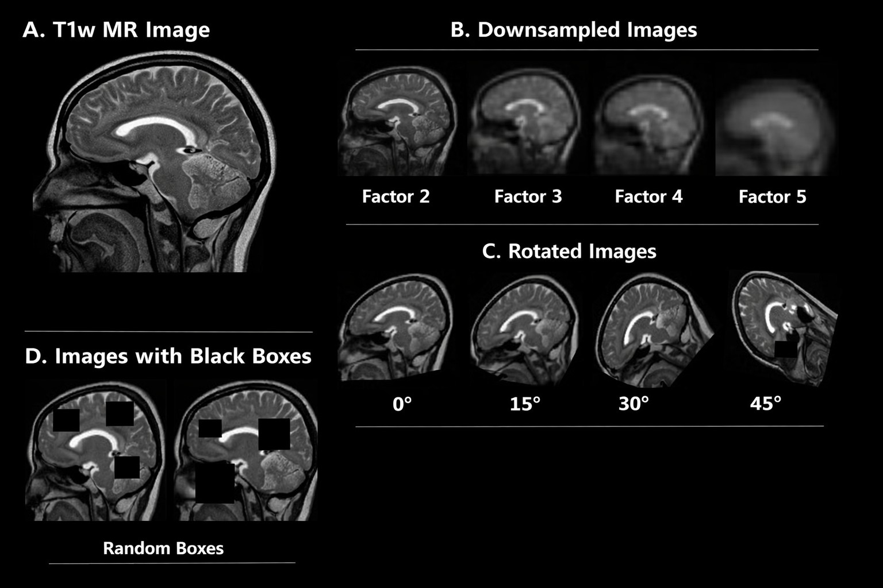
- Techniques for data augmentation on MRI scans: (A) Original T1- weighted MRI scan, (B) Down sampled MRI scans by a factor of 2, 3, 4, and 5, (C) Rotation of MRI scans at intervals of 15 degrees, and (D) Black boxes of varying sizes placed to imitate occlusions.

CC Metrics Extraction
After the CC is segmented, quantitative morphological parameters can be determined in the midline slice of the brain to describe its structural characteristics and detect any anomalies. This is an effective way to objectively quantify the growth of the CC and facilitate comparability between different patients [17]. In this study, important CC parameters, such as total area, perimeter, average thickness, and curvature, are obtained based on the segmented image. Furthermore, the CC is divided into several subregions to conduct localized analysis [21]. Common statistical measures, like the mean and standard deviation, are also calculated to ensure consistency in the extracted features.

Auto Quality Control (QC)
The automatic Quality Control (QC) has been included in the proposed methodology to assure that the segmentation of corpus callosum (CC) is reliable and that any error in the process of segmentation due to noise, motion artifacts, or inconsistency in the preprocessing step is identified. In order to check for segmentation errors automatically, the output results have been analyzed quantitatively using the QC module.
Three main parameters are considered in this study for measuring quality: segmentation similarity, boundary smooth- ness, and intensity consistency. For checking the segmentation similarity, Dice Similarity Coefficient (DSC) was considered, while for assessing boundary smoothness, contour continuity was considered. The variation of pixel intensities inside the segmented area is checked using intensity consistency.
For intensity consistency, the sample variance formula is defined as:
Automatic Quality Control (QC) for CC Segmentation
1: Input: Segmented CC image S, Ground truth (optional) G
2: Compute Dice Similarity Coefficient (DSC)
3: if DSC < Threshold₁ then
4: Flag segmentation as low quality
5: end if
6: Calculate boundary continuity measure
7: if Continuity < Threshold₂ then
8: Mark segmentation for refinement
9: end if
10: Compute intensity variance within region
11: if Variance > Threshold₃ then
12: Reprocess segmentation
13: end if
14: Output: Quality-validated segmentation result

$Dice=\frac{2|S∩G}{\left|S\right|+\left|G\right|}$ (1)
$Smoothness=\frac{{Perimeter}^{2}}{4π×Area}$ (2)
$QC Score=w_{1}∙Dice+w_{2}∙Smoothness+w_{3}∙Consistency$ (3)

Assessing Accuracy and Reliability
The efficiency of the segmentation framework has been quantitatively assessed using metrics such as the Dice Similarity Coefficient (DSC), IoU and accuracy rates. The metrics are responsible for estimating how similar are the segmented regions to their corresponding ground truth. The Dice Similarity Coefficient is defined as:
$Dice=\frac{2|S∩G}{\left|S\right|+\left|G\right|}$ (4)
Reliability and consistency metrics such as mean and standard deviation have been taken into account for testing purposes.

Applications for Biological Significance
A total of 45,336 subjects from the UK Biobank dataset were analyzed for any possible CC abnormalities through systematic screening of T1-weighted MRI scans acquired during any imaging session [22]. These structural abnormalities were classified into various categories according to their nature, such as hypoplasia (with reduced thickness of the CC throughout its extent), dysplasia (which refers to the irregular or aberrant shape of the CC), hypoplasia combined with dysplasia, and partial or complete agenesis where parts or the whole corpus callosum is absent [23].
Segmentation, extraction of morphological features, and quality control procedures were performed on all the T1-weighted MRI scans used in the study [24].
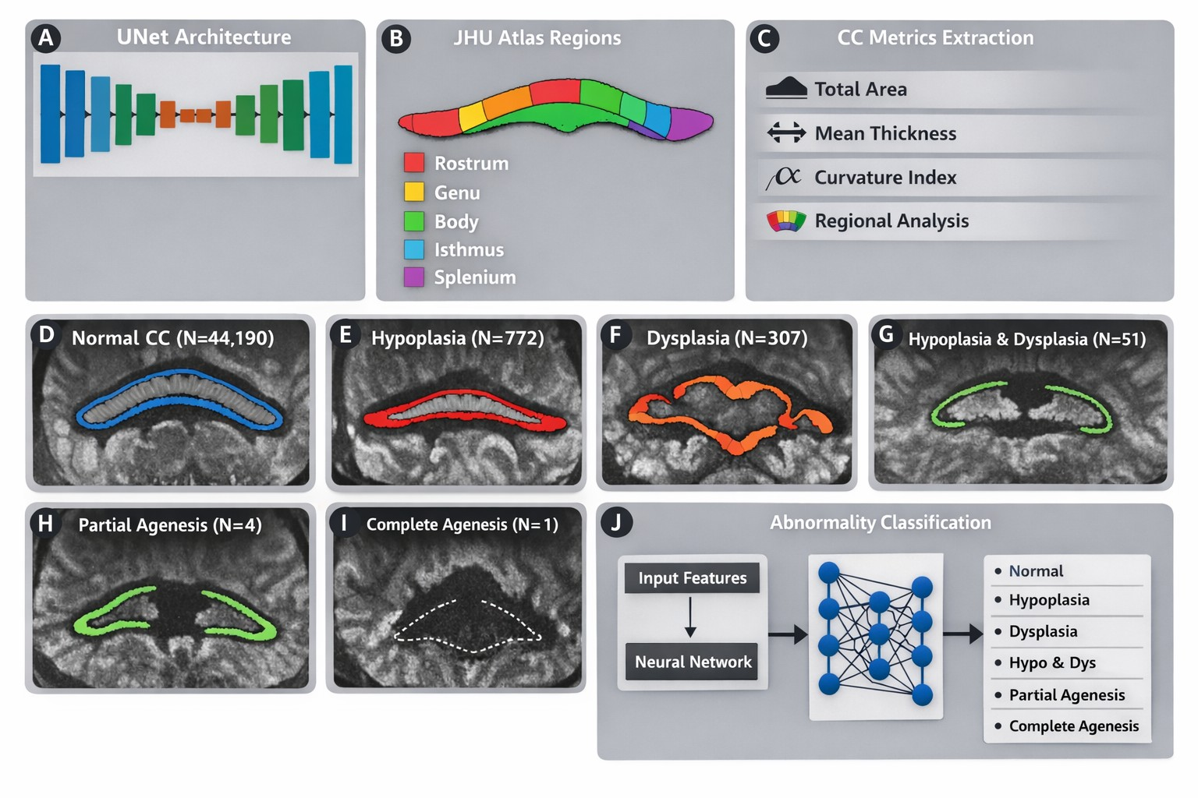
- Overview of the CC analysis framework. (A) Architecture of the U-Net for CC segmentation. (B) CC region segmentation using JHU atlas. (C) Quantitative parameters extracted from CC. (D) Example of normal CC (N=44,190). (E) Example of CC hypoplasia (N=772). (F) Example of CC dysplasia (N=307). (G) Example of combined CC hypoplasia dysplasia (N=51). (H) Example of partial CC agenesis (N=4). (I) Example of complete CC agenesis (N=1). (J) Architecture of deep
- Dataset Partitioning for UKB Data Using Shape Features in Corpus Callosum
CC Shape Category | Number of Subjects (N) | Percentage (%)
Normal Corpus Callosum | 44,190 | 97.47
Hypoplasia | 772 | 1.70
Dysplasia | 307 | 0.68
Hypoplasia with Dysplasia | 51 | 0.11
Partial Agenesis | 4 | 0.01
Complete Agenesis | 1 | 0.00
Total | 45,325 | 100

A deep learning neural network was trained to assign probability predictions to each corpus callosum anomaly category from shape-based feature inputs. MidCC structure and deep learning probability scores were integrated into a gradient boosting classifier model for normal and anomalous corpus callosum shapes. Feature importance analysis allowed determination of the most impactful features.
The heritability estimates (h2) of CC global measures were estimated by GCTA was carried out along with the genome-wide association analysis on total mid-corpus callosum (midCC) measurements. areas was performed using SAIGE. The T1-weighted magnetic resonance imaging datasets of 42,080 participants recruited from the UK Biobank were considered in this study.

Results
The effectiveness of the suggested CC analysis pipeline was validated based on sample images selected from the datasets where the image qualities were degraded or the field of views were restricted, such as slab-based MRI images from Results derived from Alzheimer’s Disease Neuroimaging Initiative and images stored in the National Alzheimer’s Coordinating Center were added to the study. Fig. 3 shows that the experiment produced positive results, and one case of partial agenesis was detected using the UK Biobank database.
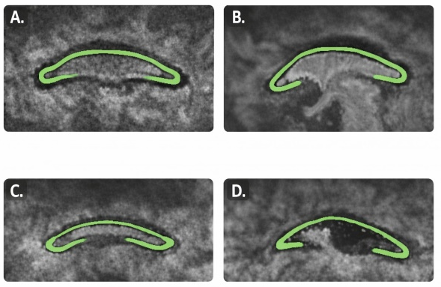
- MidCC segmentation success for – A. NACC T1 GRE low resolution/noisy image B. NACC T2 FLAIR image C. ADNI3 Hippocampus high resolution partial brain scan D. UKB patient with partial agenesis
- Comparative Performance Analysis of Models for Automated Quality Assessment Using midCC Shape Features
Model | Class | Precision | Recall | F1-score | AUC
2*3-layer NN | Pass  Fail | 0.96  0.93 | 0.99  0.74 | 0.97  0.83 | 2*0.866
2*Wide/Deep NN | Pass  Fail | 0.96  0.88 | 0.98  0.75 | 0.97  0.81 | 2*0.866
2*XGBoost | Pass  Fail | 0.96  0.94 | 0.99  0.74 | 0.98  0.83 | 2*0.868
2*Ensemble | Pass  Fail | 0.96  0.96 | 0.99  0.73 | 0.98  0.83 | 2*0.864

Validation results for CC Segmentation and AutoQC
The efficacy of the developed automatic corpus callosum segmentation method and the quality control process was validated through a set of quantitative criteria in order to guarantee precision and reliability. For the validation of the segmentations, metrics such as Dice Similarity Coefficient (DSC), boundary smoothness and region consistency were used. The AutoQC algorithm was able to detect low-quality or non-conformant segmentations based on the thresholding of certain metrics values. Low DSC value or poor boundary properties automatically resulted in the detection of such segmentations. As shown by the experimental results, the proposed approach allowed achieving high segmentation accuracy and robustness with respect to different imaging conditions. In general, the validation results prove the effectiveness of the implementation of automated QC processes within the CC segmentation pipeline.

Abnormality classification results
Classification accuracy on the UKB test dataset demonstrated satisfactory performance for the Normal, CCD, and CCH groups, with accuracy values of 0.80, 0.80, and 0.93, respectively. Fig. 4 presents a bar graph illustrating the most significant features contributing to the classification process. These features were derived from neural network outputs as well as measurements of overall and regional corpus callosum (CC) thickness.
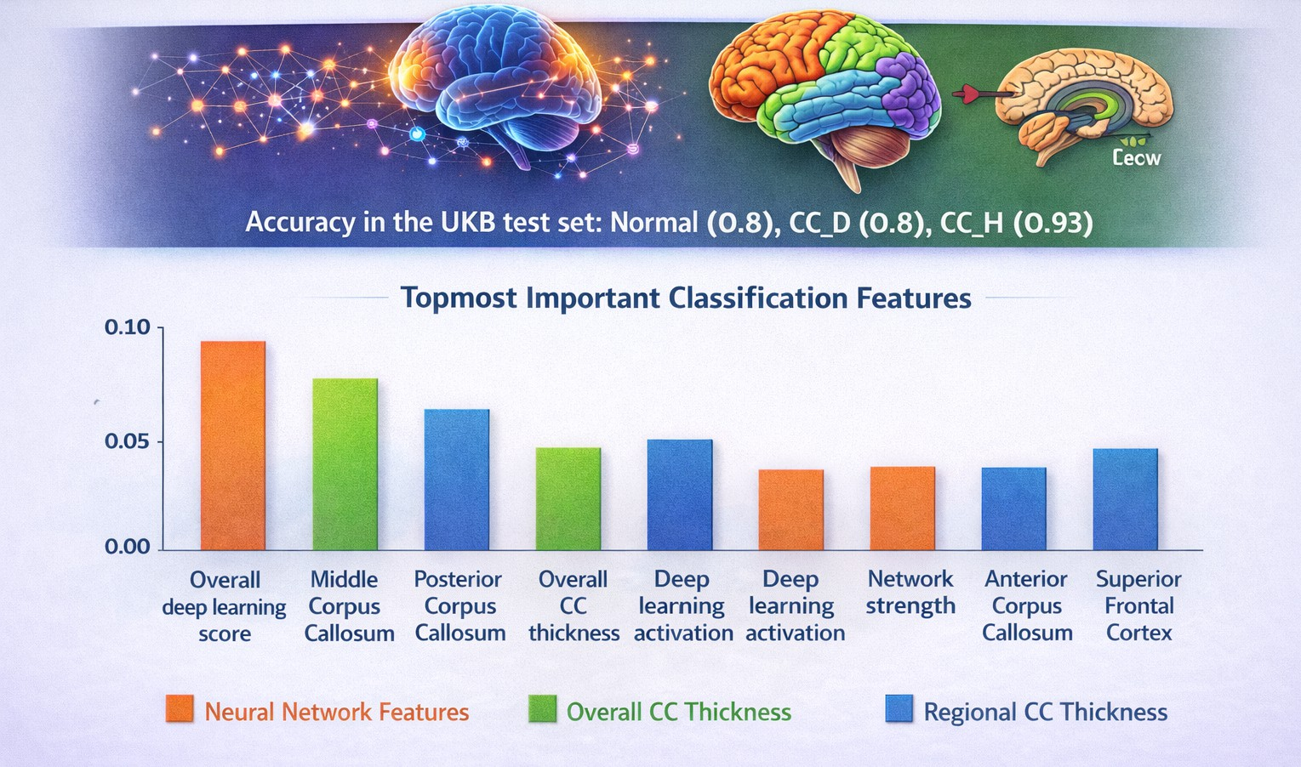
- Neural network-based scores and both global and regional corpus callosum (CC) thickness exhibit strong discriminative capability for classifying normal and abnormal cases. On the UKB test dataset, the model achieved accuracies of 0.8 for Normal, 0.8 for CC D, and 0.93 for CC H.

Testing on a Test-Retest Dataset
The mean Dice similarity coefficient between the automatically generated corpus callosum (CC) masks and the manually delineated masks was 0.941 across all participants, indicating strong agreement between automated and manual segmentations. The mean intraclass correlation coefficient (ICC) values for all CC measurements obtained from repeated sessions across subjects are presented in Fig. 5.
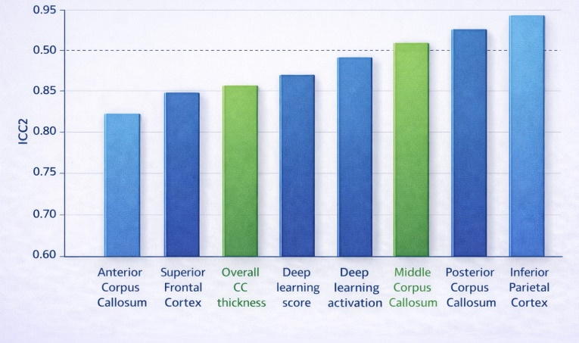
- The ICC2 values derived from the HNU test–retest data for all CC measures are illustrated in the following figure. This chart illustrates the reliability of CC thickness measurements, whether they are regional or global measurements.

Heritability and Genome-Wide Association Results
Heritability estimates for all global mid-corpus callosum (midCC) variables are provided in Table 4. The results revealed high heritability across all measured characteristics, with the maximum value for the heritability of total midCC area (h² =0.71, SE =0.015). Furthermore, there is evidence of a weak, statistically significant genetic correlation between total midCC area and FA (r_{G} = 0.14, SE = 0.022).
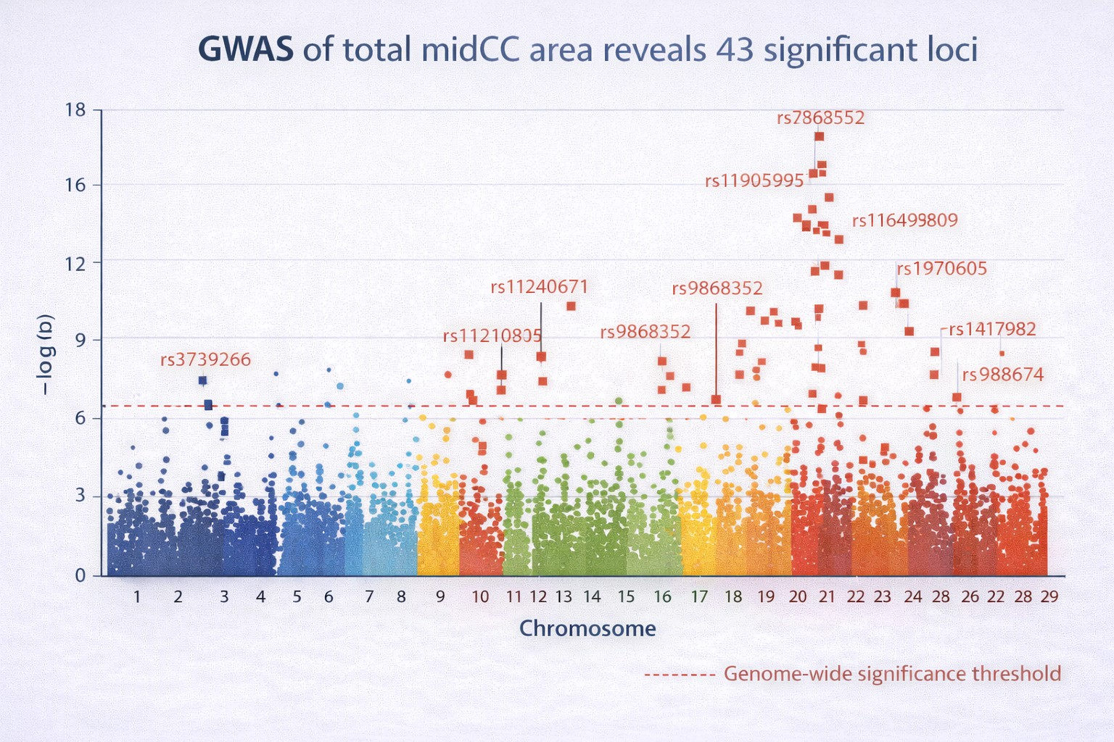
- Genome-wide association study (GWAS) results for the total mid- corpus callosum (midCC) area conducted using the SAIGE method. The Manhattan plot shows the distribution of association signals across chromosomes, with 43 loci exceeding the genome-wide significance threshold.
- Heritability Analysis for Mid-Corpus Callosum (midCC) Measurements in a Big Sample Population (N= 42,080)
Metric | Heritability (h²) | SE
Total Area of midCC | 0.71 | 0.015
Anterior midCC Thickness | 0.64 | 0.014
Middle midCC Thickness | 0.66 | 0.013
Posterior midCC Thickness | 0.69 | 0.012
Genu Thickness | 0.62 | 0.016
Body Thickness | 0.65 | 0.014
Splenium Thickness | 0.68 | 0.013
Fractional Anisotropy (FA) | 0.58 | 0.017

Discussion and Conclusion
Here, a highly versatile multimodal system is presented to perform automatic segmentation and quantitative analyses on the midsagittal corpus callosum (CC). This approach incorporates both segmentation, quality assessment, and quantification in an integrated system. This allows for the consistent and efficient evaluation of the CC structure on different types of MRI data, namely T1w, T2, and FLAIR MRI.
The good Dice similarity coefficient values derived from comparison of automated and manual CC segmentation pro- vide an indication of very precise segmentation and high degree of conformity between the two approaches. Addition- ally, the ICC results for multiple scans indicate the reliability and repeatability of CC measures derived using the proposed methodology, which implies that this technique is capable of accommodating long-term longitudinal studies involving population-wide analysis.
Besides the segmentation accuracy, the structural metrics obtained from the automatic extraction process, such as CC thickness and volume both globally and regionally, are useful quantitative metrics for studying neurodevelopmental and degenerative processes. Heritability and genome-wide association study findings revealed the biological significance of these measures because the results showed that there is a strong genetic component underlying individual differences in CC structure. Finding loci in the genome linked to certain CC traits proves the utility of automated metrics in neuroimaging genetics studies [15].
In summary, the suggested approach represents a scalable solution that can be used for automated corpus callosum analyses for scientific and medical purposes. In future studies, we plan to extend our framework for other brain structures, improve segmentation performance using deep-learning techniques, and investigate possible associations with other clinical and genetic conditions.

References
- L. K. Paul, “Developmental malformation of the corpus callosum: A review of typical callosal development and examples of developmental disorders with callosal involvement,” J. Neurodev. Disord., vol. 3, no. 1, 2011.
- C. Adamson et al., “Software pipeline for midsagittal corpus callosum thickness profile processing: Automated segmentation, manual editor, thickness profile generator, group-wise statistical comparison and results display,” Neuroinformatics, vol. 12, no. 4, pp. 595–614, 2014.
- M. Boccardi et al., “Survey of protocols for the manual segmentation of the hippocampus: Preparatory steps towards a joint EADC-ADNI harmonized protocol,” J. Alzheimer’s Dis., vol. 26, Suppl. 3, pp. 61–75, 2011.
- C. Guo et al., “Repeatability and reproducibility of FreeSurfer, FSL- SIENAX and SPM brain volumetric measurements and the effect of lesion filling in multiple sclerosis,” Eur. Radiol., vol. 29, no. 3, pp. 1355–1364, 2019.
- B. Van Ginneken et al., “Active shape model segmentation with optimal features,” IEEE Trans. Med. Imaging, vol. 21, no. 8, pp. 924–933, 2002.
- C. Vachet et al., “Automatic corpus callosum segmentation using a deformable active Fourier contour model,” in Proc. SPIE, vol. 8317, 2012.
- T. McInerney and D. Terzopoulos, “Deformable organisms for automatic medical image analysis,” Med. Image Anal., vol. 6, no. 3, pp. 251–266, 2002.
- B. Ardekani, “Automatic Registration Toolbox,” 2013. [Online]. Avail- able: http://www.nitrc.org/projects/art
- C. L. Adamson et al., “Thickness profile generation for the corpus callosum using Laplace’s equation,” Hum. Brain Mapp., vol. 32, no. 12, pp. 2131–2140, 2011.
- S. Das et al., “Corpus callosum atrophy in detection of mild and moderate Alzheimer’s disease using brain magnetic resonance image processing and machine learning techniques,” J. Alzheimer’s Dis. Rep., vol. 5, no. 1, 2021.
- F. Isensee et al., “Automated brain extraction of multisequence MRI using artificial neural networks,” Hum. Brain Mapp., vol. 40, no. 17, pp. 4952–4964, 2019.
- B. Thyreau et al., “Segmentation of the hippocampus by transferring algorithmic knowledge for large cohort processing,” Med. Image Anal., vol. 43, pp. 214–228, 2018.
- L. Henschel et al., “FastSurfer: A fast and accurate deep learning-based neuroimaging pipeline,” NeuroImage, vol. 219, 2020.
- M. Platten et al., “Deep learning corpus callosum segmentation as a neurodegenerative marker in multiple sclerosis,” J. Neuroimaging, vol. 31, no. 3, pp. 493–500, 2021.
- D. Dima et al., “Subcortical volumes across the lifespan: Data from 18,605 healthy individuals aged 3–90 years,” Hum. Brain Mapp., vol. 43, no. 1, pp. 452–469, 2022.
- R.-A. Mu¨ller, “The study of autism as a distributed disorder,” Ment. Retard. Dev. Disabil. Res. Rev., vol. 13, no. 1, pp. 85–95, 2007.
- A. H. Zhu et al., “Robust automatic corpus callosum analysis toolkit: Mapping callosal development across heterogeneous multisite data,” in Proc. SIPAIM, 2018.
- J. D. Tournier et al., “MRtrix3: A fast, flexible and open software frame- work for medical image processing and visualisation,” NeuroImage, vol. 202, p. 116137, 2019.
- M. Liu et al., “Style transfer using generative adversarial networks for multi-site MRI harmonization,” in Proc. MICCAI, vol. 12903, pp. 313– 322, 2021.
- O. Ronneberger et al., “U-Net: Convolutional networks for biomedical image segmentation,” in Proc. MICCAI, vol. 9351, 2015.
- S. Wakana et al., “Fiber tract–based atlas of human white matter anatomy,” Radiology, vol. 230, no. 1, 2004.
- R. M. Hanna et al., “Distinguishing three classes of corpus callosal abnormalities in consanguineous families,” Neurology, vol. 76, no. 4, pp. 373–382, 2011.
- J. Yang et al., “GCTA: A tool for genome-wide complex trait analysis,” Am. J. Hum. Genet., vol. 88, no. 1, pp. 76–82, 2011.
- W. Zhou et al., “Efficiently controlling for case-control imbalance and sample relatedness in large-scale genetic association studies,” Nat. Genet., vol. 50, no. 9, pp. 1335–1341, 2018.

